CPU [Central Processing Unit]. It is the brain of the computer. It is the part that does most of the work in a computer system. Just like how our brain controls our body and processes information, the CPU carries out instructions from programs and performs calculations. It’s made up of smaller components that work together to execute tasks, making it the heart of any computing device.
All types of data processing operations from simple arithmetic to complex tasks and all the important functions of a computer are performed by the CPU. It helps input and output devices to communicate with each other and perform their respective operations. It also stores data which is input, intermediate results in between processing, and instructions. The CPU’s job is to make sure everything runs smoothly and efficiently. In this article, we are going to discuss CPU in detail.

What is a CPU?

A Central Processing Unit is the most important component of a computer system. A CPU is hardware that performs data input/output, processing, and storage functions for a computer system. A CPU can be installed into a CPU socket. These sockets are generally located on the motherboard. CPU can perform various data processing operations. CPU can store data, instructions, programs, and intermediate results.
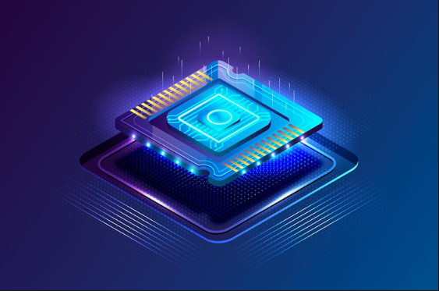

History of CPU

Since 1823, when Baron Jons Jakob Berzelius discovered silicon, which is still the primary component used in manufacturing CPUs today, the history of the CPU has experienced numerous significant turning points. The first transistor was created by John Bardeen, Walter Brattain, and William Shockley in December 1947. in 1958, the first working integrated circuit was built by Robert Noyce and Jack Kilby.
The Intel 4004 was the company’s first microprocessor, which it unveiled in 1971. Ted Hoff’s assistance was needed for this. When Intel released its 8008 CPU in 1972, Intel 8086 in 1976, and Intel 8088 in June 1979, it contributed to yet another win. The Motorola 68000, a 16/32-bit processor, was also released in 1979. The Sun also unveiled the SPARC CPU in 1987. AMD unveiled the AM386 CPU series in March 1991.
In January 1999, Intel introduced the Celeron 366 MHZ and 400 MHz processors. AMD back in April 2005 with its first dual-core processor. Intel also introduced the Core 2 Dual processor in 2006. Intel released the first Core i5 desktop processor with four cores in September 2009.
In January 2010, Intel released other processors like the Core 2 Quad processor Q9500, the first Core i3 and i5 mobile processors, and the first Core i3 and i5 desktop processors.
In June 2017, Intel released Core i9 desktop processor, and Intel introduced its first Core i9 mobile processor In April 2018.

Different Parts of CPU
3 major units:
- Memory or Storage Unit
- Control Unit
- ALU(Arithmetic Logic Unit)
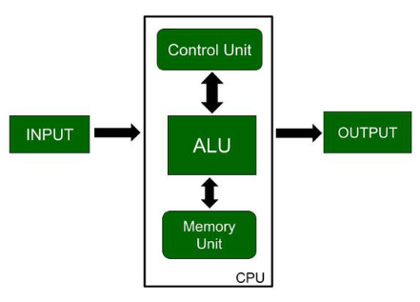

Memory or Storage Unit

As the name suggests this unit can store instructions, data, and intermediate results. The memory unit is responsible for transferring information to other units of the computer when needed. It is also known as an internal storage unit or the main memory or the primary storage or Random Access Memory (RAM) as all these are storage devices.
Its size affects speed, power, and performance. There are two types of memory in the computer, which are primary memory and secondary memory. Some main functions of memory units are listed below:
- Data and instructions are stored in memory units which are required for processing.
- It also stores the intermediate results of any calculation or task when they are in process.
- The final results of processing are stored in the memory units before these results are released to an output device for giving the output to the user.
- All sorts of inputs and outputs are transmitted through the memory unit.

Control Unit
As the name suggests, a control unit controls the operations of all parts of the computer but it does not carry out any data processing operations. Executing already stored instructions, It instructs the computer by using the electrical signals to instruct the computer system. It takes instructions from the memory unit and then decodes the instructions after that it executes those instructions. So, it controls the functioning of the computer. Its main task is to maintain the flow of information across the processor. Some main functions of the control unit are listed below:
- Controlling of data and transfer of data and instructions is done by the control unit among other parts of the computer.
- The control unit is responsible for managing all the units of the computer.
- The main task of the control unit is to obtain the instructions or data that is input from the memory unit, interpret them, and then direct the operation of the computer according to that.
- The control unit is responsible for communication with Input and output devices for the transfer of data or results from memory.
- The control unit is not responsible for the processing of data or storing data.

ALU (Arithmetic Logic Unit)
ALU (Arithmetic Logic Unit) is responsible for performing arithmetic and logical functions or operations. It consists of two subsections, which are:
- Arithmetic Section: By arithmetic operations, we mean operations like addition, subtraction, multiplication, and division, and all these operations and functions are performed by ALU. Also, all the complex operations are done by making repetitive use of the mentioned operations by ALU.
- Logic Section: By Logical operations, we mean operations or functions like selecting, comparing, matching, and merging the data, and all these are performed by ALU.
Note: The CPU may contain more than one ALU and it can be used for maintaining timers that help run the computer system.

What Does a CPU Do?

The main function of a computer processor is to execute instructions and produce an output. CPU work Fetch, Decode, and Execute are the fundamental functions of the computer.
- Fetch: the first CPU gets the instruction. That means binary numbers that are passed from RAM to CPU.
- Decode: When the instruction is entered into the CPU, it needs to decode the instructions. with the help of ALU(Arithmetic Logic Unit), the process of decoding begins.
- Execute: After the decode step the instructions are ready to execute.
- Store: After the execute step the instructions are ready to store in the memory.

Types of CPU

- Single Core CPU: The oldest type of computer CPU is a single-core CPU. These CPUs were used in the 1970s. these CPUs only have a single core that performs different operations. This means that the single-core CPU can only process one operation at a single time. single-core CPU CPU is not suitable for multitasking.
- Dual-Core CPU: Dual-Core CPUs contain a single Integrated Circuit with two cores. Each core has its cache and controller. These controllers and cache work as a single unit. dual-core CPUs can work faster than single-core processors.
- Quad-Core CPU: Quad-Core CPUs contain two dual-core processors present within a single integrated circuit (IC) or chip. A quad-core processor contains a chip with four independent cores. These cores read and execute various instructions provided by the CPU. Quad Core CPU increases the overall speed of programs. Without even boosting the overall clock speed it results in higher performance.

What is CPU Performance?
CPU performance is how fast a computer’s processor (CPU) can complete the task. It is measured by the number of instructions completed in one second. Its performance depends on the processor’s clock speed and other factors like its design and the size of its cache.
What are Computer Programs and Where are They Stored?
A computer program is a set of instructions written by a programmer that tells a computer what to do. For example, Using a web browser or a word processor is a program, Performing math operations on a computer and clicking and selecting items with a mouse or touchpad is also a program.

Storage of Programs
- Permanent Storage: Programs are stored permanently on storage devices like HDD, or SSD.
- Temporary Storage: When a program is running on a CPU, its data is stored in RAM from HDD or SDD. Temporary because RAM is volatile, it loses all data when the power is turned off.

Advantages
- Versatility: CPU can able to handle a complex task, from basic calculation to managing the operating system.
- Performance: Modern CPU are vary fast and able to perform billions of calculation per second.
- Multi-core: CPU have multiple core and able to handle multiple task simultaneously.
- Compatibility: CPUs are designed to be compatible with a wide range of software, this help to run different applications by using single CPU.

Disadvantages
- Overheating: CPU generate a lot of heat while performing complex task. This requires effective cooling solutions, such as fans or liquid cooling systems.
- Power Consumption: High-performance CPUs can consume a vary high amount of power, which cause to generate higher electricity bills and the need for a robust power supply.
- Cost: Best performance CPU can be expensive. Which can be a barrier for some users or applications that need high computing power.
- Limited Parallel Processing: While multi-core CPUs can handle multiple tasks at once, they are still not as efficient at parallel processing as specialized hardware like GPUs (Graphics Processing Units), which are designed for handling many tasks simultaneously.

